**COMP3121 Assignment 5 – Question 2**

**2) NOTE: The below solution is for the old question 2 before Aleks emailed us the new version, i.e. solution for the specified *8 x 8* chessboard, however I believe it should also satisfy the updated version of Q2 that Aleks emailed us on 01/08/2020. I basically followed a general problem-solving approach to solving the *8 x 8* board which can also be applied to the situation of a *n x n* board. However, the maximum number of non-attacking rooks that we can place will obviously be different for the *n x n* board situation.**

We are given a regular 8 x 8 **(or *n x n*)** chess board with two white bishops on squares $(a, b)$ and $(c, d)$ where $\left(1≤a, b, c, d≤8\right)$ and the bishops are placed on squares of opposite colours. We are required to find the maximum number of black rooks that we can place on the board where no two rooks are in the same column or row as each other and the rooks cannot be placed in the attack range of the bishops (i.e. diagonal of the bishops).

We can solve this by thinking of the chessboard as a bipartite graph, where the columns are vertices on the left and rows are vertices on the right. We will have a super source with infinite edge capacities connected to the columns and a super source with infinite edge capacities connected to the rows. We can now represent each square in row *i* and column *j* as $s_{ij}$.

See below for an overall visual diagram (taken from lecture notes) for what we are trying to achieve:

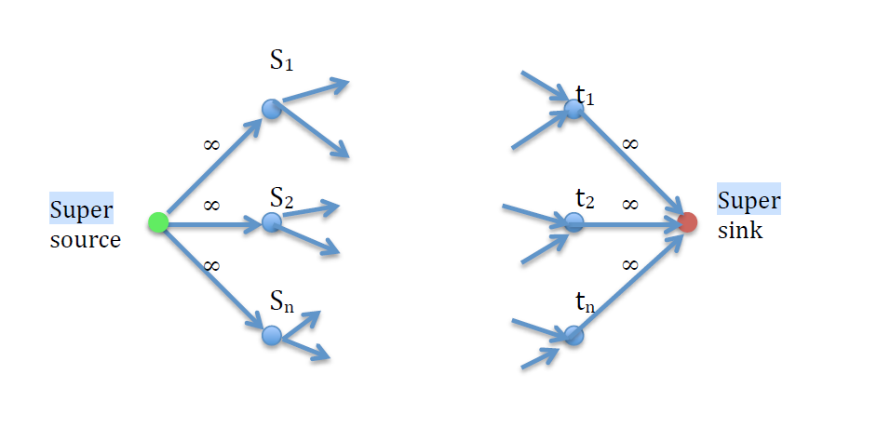

Going back to the bishops, for a bishop that can only go on a white square, it is limited to only half of the board (as half of the squares on a chessboard are white) and the same thing for a bishop on a black square. This means that the diagonal attack range for these bishops will not ever overlap as they are placed on squares of differing colours. Additionally, the diagonals of a bishop will satisfy the equations $y=x$ and $y= -x$. So, for a bishop of square (4, 3) its attack range will satisfy the above equations (obviously limited to the boundaries of the chessboard). Hence, for a bishop on square $(i, j)$, its attack range (diagonals) will be of the forms: $y_{1}+j=x_{1}+i$ and $y_{2}+j= -x_{2}+i$. Hence, we simply remove the edges in the bipartite graph which correspond to the above square ranges. For example, if a bishop was on square (5, 2) then the edges we would remove would correspond to the squares: (4, 1), (5, 2), (6, 3), (7, 4), (8, 5) for $y_{1}+j=x_{1}+i$ and squares (6, 1), (5, 2), (4, 3), (3, 4), (2, 5), (1, 6) for $y_{2}+j= -x_{2}+i$. Notice that square (5, 2) [or (i, j)] occurs twice in total for the above equations (as it is essentially our origin point).

So, once we have removed the edges of our origin square $(i, j)$ and its corresponding diagonal attack range squares for both of our bishops, we can then determine the largest number of rooks that we can place on the board such that no two rooks will lie on the same column or row as each other. We know that for an $n*n$ chessboard, the maximum number of non-attacking rooks that can be placed is *n* rooks (in this case since we have an 8 x 8 chessboard, the maximum number of non-attacking rooks that can be placed is 8 rooks). However, when we consider the blocked squares resulting from the attack ranges of both bishops, we will remove them from our set of vertices on the left (L) (columns) and right (R) (rows) where $j∈L and i∈R.$ For any $s_{ij}$ that has been filled, we will remove it from our bipartite graph. Once we have this, we can then do some bipartite matching where for every rook that has been placed down, any corresponding square in the same column or row of that rook position on square (i, j) will also be removed from the graph. We then turn this problem from a maximum matching into a max-flow problem where we will give all edges from L to R a capacity of 1. We can apply the Edmonds-Karp algorithm to then find the maximum number of non-attacking rooks that we can place down which are not in the attack range of the bishops, and this would be a maximum of 8 rooks **(or ‘*n’* rooks – for the updated version of the question if we consider a *n x n* chessboard)**, having a time complexity of $O(\left|V\right|{ \left|E\right|}^{2})$.

**End of Solution**

Sources used:

* Stack Overflow (for bishop attack range equations): <https://codereview.stackexchange.com/questions/146935/find-diagonal-positions-for-bishop-movement>
* Lecture notes on Maximal Flow